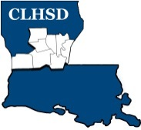
Central Louisiana Human Services District
Board Meeting Agenda
April 6, 2023

- Call to Order/Quorum
- Prayer/Pledge

- Read and Approve April 2023 Meeting Agenda
Solicit Public Comment Requests

- Approval of Minutes
March 2023 Board Meeting Minutes / Board Meeting & Retreat Minutes
- District Reports

  - Financial Report H1
  - ED Monthly Report H2

- Policy Reviews
Executive Limits
  - II. H. Compensation and Benefits -H3
  - II. K. Community Relationships - H4 and H4a (Community Engagement Report)

- Board Business
- Board Development/Training – Contracts - presentation by a current contractor
- Tier 2.1- Calendar Year 2022 due by May 15th – link emailed to members
- Annual Ethics Training – Link emailed to members

- Next Month
- Annually Ethics training & tier 2.1 to be completed by the May meeting
- Board Member Self -Assessment distributed
- II.F. Emergency ED Succession w/procedure
- Training Topic – District Advisory Council Presentation

- Questions/Comments As Solicited

- Announcements
- Next meeting is May 4, 2023
- Adjourn

